Task 4 Report: Complex Form Validation and Dynamic DOM Manipulation

Objective
The objective of this task is to enhance form functionality by implementing complex validation rules, enabling dynamic updates to the Document Object Model (DOM) based on user interaction, and improving navigation through client–server routing.
This task focuses on creating a more interactive, responsive, and user-friendly web application experience.
Tools and Technologies
- HTML – For creating structured and accessible form elements.
- CSS – For styling form elements and dynamic UI updates.
- JavaScript – For complex validation logic and DOM manipulation.
- Node.js & Express – For handling client-server routing.
- Browser – For testing dynamic behavior and user interactions.
- Procedure

Step 1: Enhanced Form Structure
- The form was extended with multiple input fields such as:
  - Username
  - Email
  - Password and Confirm Password
  - Additional conditional fields
- Fields were grouped logically to improve clarity and usability.
- Required fields were clearly identified to guide the user.

Step 2: Complex Form Validation
- Advanced validation rules were implemented, including:
  - Password strength validation (length, uppercase, lowercase, numbers, special characters).
  - Matching password and confirm password fields.
  - Email format and uniqueness checks.
  - Input length and character restrictions.
- Validation messages were displayed in real time to inform users of errors.
- Multiple validation rules were checked simultaneously to ensure complete data accuracy.

Step 3: Dynamic DOM Manipulation
- The DOM was dynamically updated based on user interactions:
  - Error messages appeared or disappeared instantly based on input validity.
  - Form sections were shown or hidden dynamically depending on user choices.
  - Buttons were enabled or disabled based on form completion status.
- These dynamic updates improved usability and reduced form submission errors.

Step 4: Client–Server Routing
- Client-server routing was implemented to provide a smooth navigation experience.
- Form submission and page updates occurred without full page reloads.
- Users were redirected to confirmation or error views dynamically based on validation results.
- Routing improved performance and provided a seamless flow between pages.

Step 5: Testing and Validation
- The form was tested with:
  - Valid inputs to confirm successful submission.
  - Invalid inputs to verify error handling and dynamic feedback.
- Dynamic DOM updates were verified for different user actions.
- Routing behaviour was tested to ensure smooth navigation between views.

4. Observations
- Complex validation significantly reduced incorrect form submissions.
- Dynamic DOM updates provided immediate user feedback.
- User experience improved due to reduced page reloads.
- Client-server routing enhanced performance and navigation smoothness.
- The form became more interactive and intuitive.

5. Screenshots
Complex Form Layout
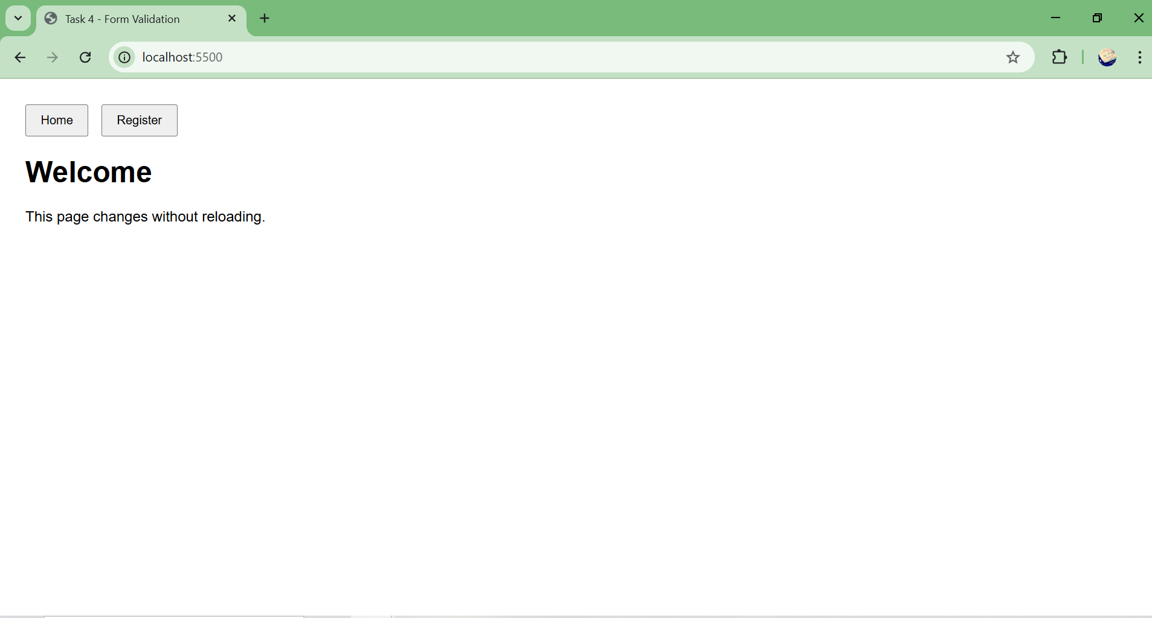
Real-Time Validation Messages
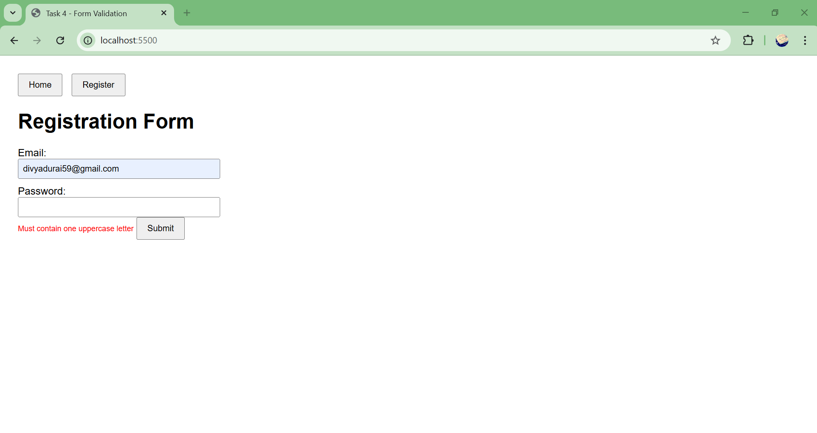Client-Server Routing Output
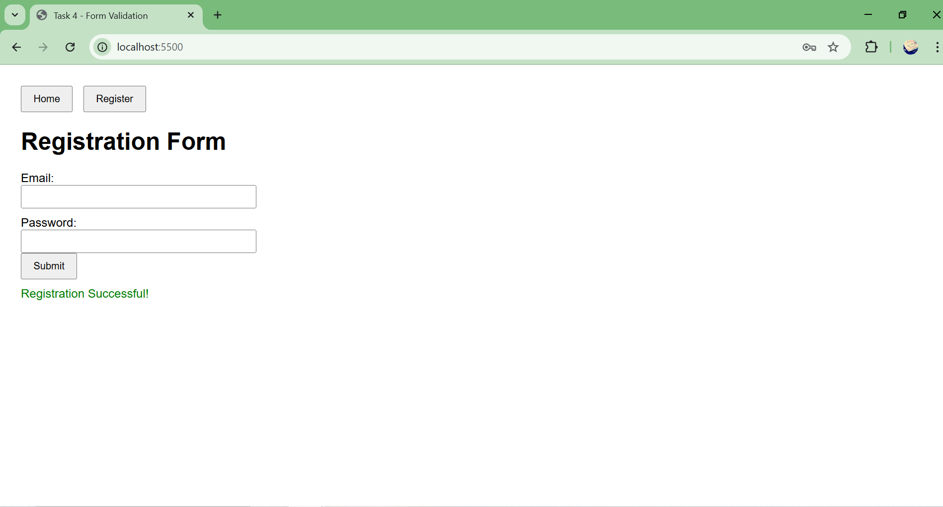

Conclusion
This task successfully demonstrates:
- Implementation of complex form validation rules.
- Use of JavaScript for dynamic DOM manipulation.
- Improved interactivity through real-time feedback.
- Seamless navigation using client-server routing.
Overall, this task enhances both data accuracy and user experience, making the application more robust and user-friendly.

